Sample Word File
This file is for testing purposes only.
Welcome to FreeTestFiles.com, a reliable platform dedicated to providing free test files for testing and educational purposes.
Our goal is to help developers, network engineers, students, system administrators, and everyday users access high-quality test files easily and instantly. Whether you need files for internet speed testing, software validation, device compatibility checks, or media testing, we offer a wide range of sample files to meet your needs.
FreeTestFiles.com provides multiple file formats, including PDF, Word, Excel, Audio, Video, ZIP, and large test files. All files are hosted on reliable servers with 24×7 availability to ensure fast and uninterrupted downloads.
We focus on simplicity, security, and accessibility. No registration is required, and all files are available for free. Our platform is regularly updated to ensure accurate and dependable testing resources.
If you have any questions or suggestions, feel free to contact us. We are always happy to help.

Our Purpose
In today’s digital world, testing is an essential part of everyday work. Whether you are checking internet speed, testing software compatibility, validating upload limits, evaluating device performance, or learning how different file formats behave, you need clean and trustworthy sample files.
FreeTestFiles.com was created to solve this exact problem by offering a centralized collection of commonly used test files in multiple formats and sizes.

We’d love to hear from you!
If you have any questions, feedback, or suggestions regarding our test files or website, feel free to reach out to us. You can also contact us if you experience any issues while downloading files or would like to request a specific test file.
📧 Email: contact@freetestfiles.com
We aim to respond to all inquiries within 24–48 hours.
Thank you for using FreeTestFiles.com.
What We Offer
We provide a wide range of sample and test files, carefully structured to meet real-world testing needs. These include:
- Sample PDF files for document and printer testing
- Word, Excel, and PowerPoint files for office and upload testing
- Audio files for media playback and compatibility checks
- Video files for resolution, format, and streaming tests
- ZIP files for compression and extraction testing
- Large files for internet speed, bandwidth, and download stability testing
Each file is created solely for testing and educational purposes and does not contain copyrighted, licensed, or proprietary content.

Our Purpose
In today’s digital world, testing is an essential part of everyday work. Whether you are checking internet speed, testing software compatibility, validating upload limits, evaluating device performance, or learning how different file formats behave, you need clean and trustworthy sample files.
FreeTestFiles.com was created to solve this exact problem by offering a centralized collection of commonly used test files in multiple formats and sizes.
Our Commitment to Quality & Safety
All files available on FreeTestFiles.com are:
- Created specifically for testing purposes
- Free from malicious scripts or executable code
- Regularly reviewed to ensure accuracy and usability
We do not host pirated software, copyrighted media, or unauthorized content. User safety and trust are always our top priorities.

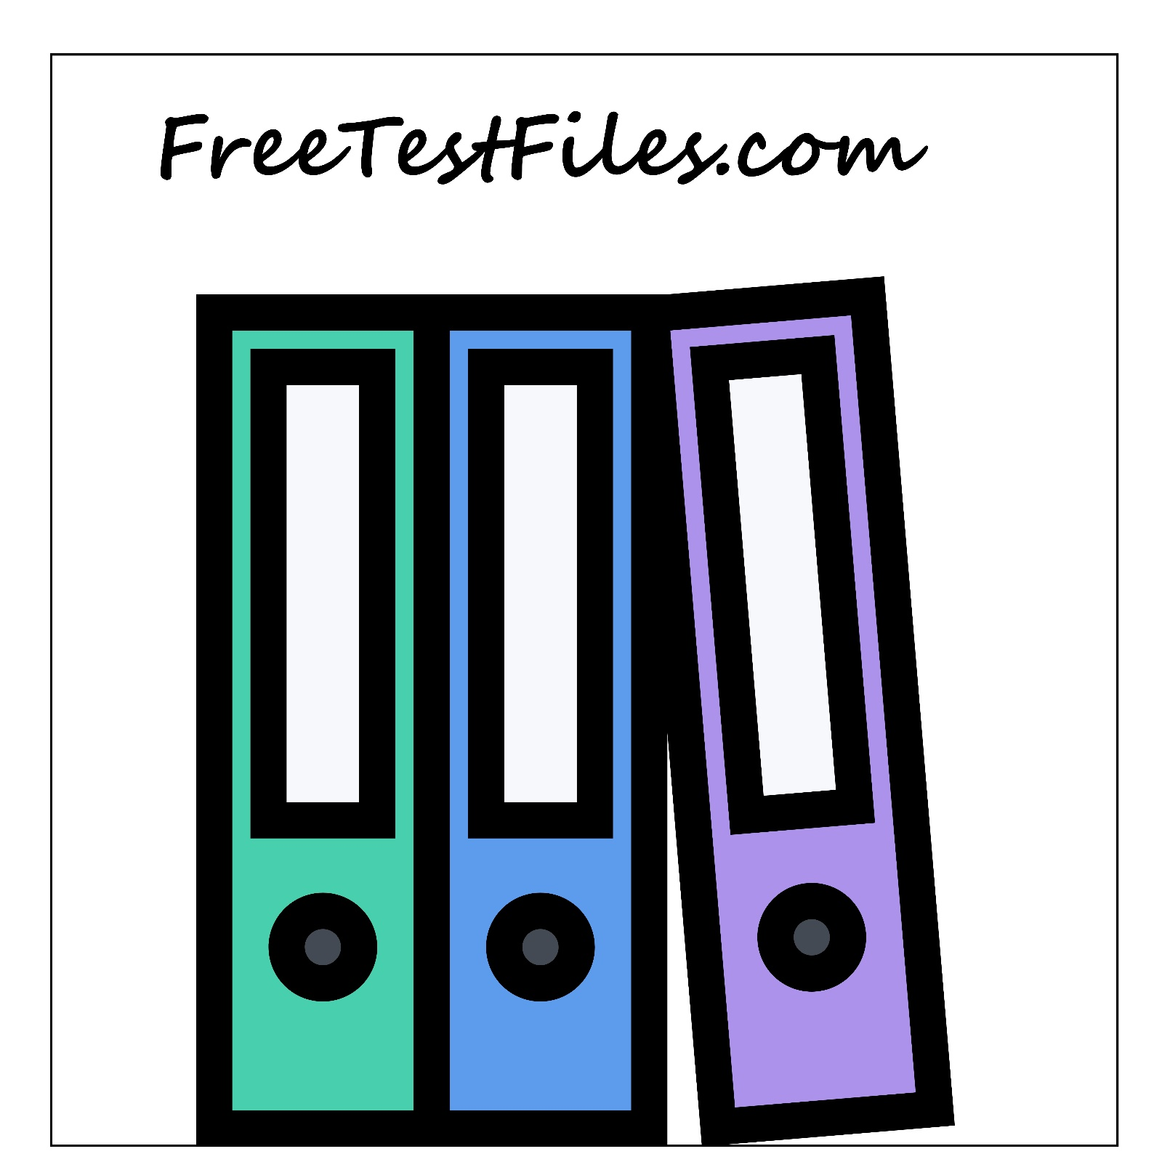

Continuous Improvement
We are continuously working to:
- Expand file formats and sizes based on real demand
- Improve website performance and usability
- Ensure compatibility across devices and browsers
User feedback plays an important role in shaping future improvements.
Thank You
Thank you for visiting FreeTestFiles.com.
We hope our resources help you test, learn, and work more efficiently.
Our Purpose
In today’s digital world, testing is an essential part of everyday work. Whether you are checking internet speed, testing software compatibility, validating upload limits, evaluating device performance, or learning how different file formats behave, you need clean and trustworthy sample files.
FreeTestFiles.com was created to solve this exact problem by offering a centralized collection of commonly used test files in multiple formats and sizes.
Get in Touch
If you have questions, suggestions, or feedback, feel free to contact us:
📧 Email: contact@freetestfiles.com
We value user input and strive to make FreeTestFiles.com more useful every day.

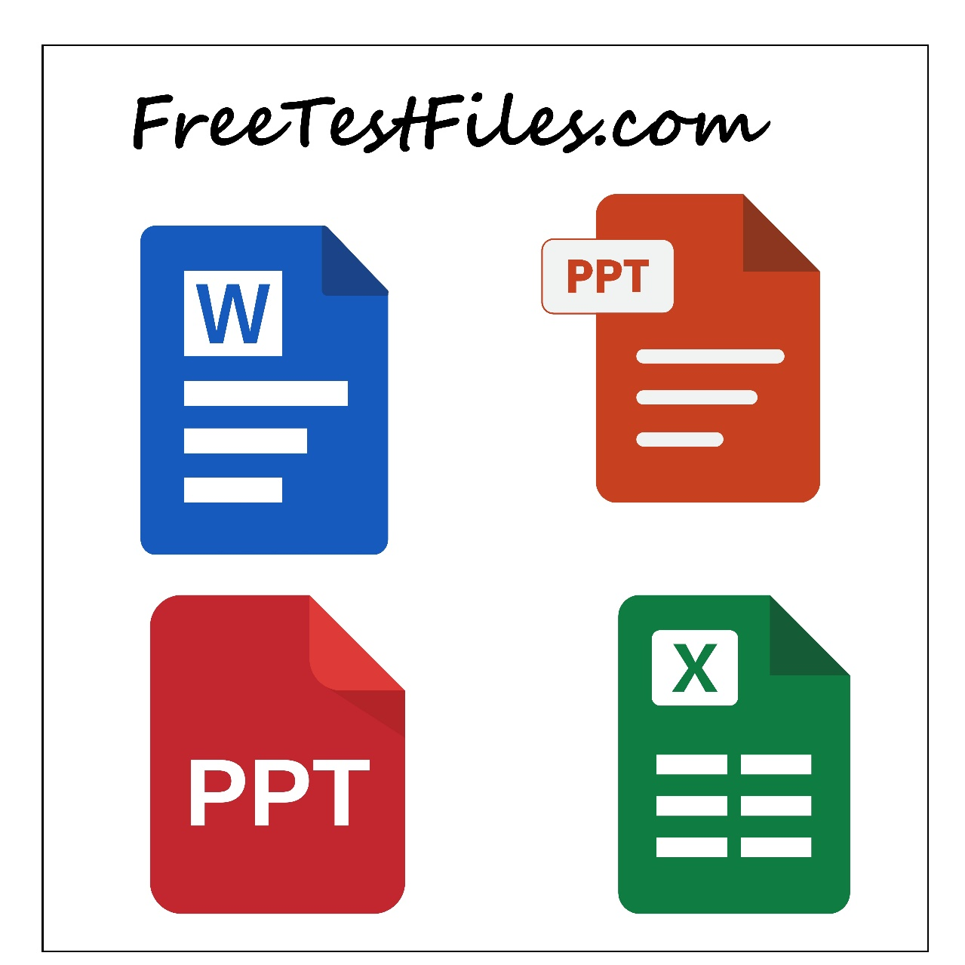
Get in Touch
If you have questions, suggestions, or feedback, feel free to contact us:
📧 Email: contact@freetestfiles.com
We value user input and strive to make FreeTestFiles.com more useful every day.

