Sample Word File
This file is for testing purposes only.
Welcome to FreeTestFiles.com, a reliable platform dedicated to providing free test files for testing and educational purposes.
Our goal is to help developers, network engineers, students, system administrators, and everyday users access high-quality test files easily and instantly. Whether you need files for internet speed testing, software validation, device compatibility checks, or media testing, we offer a wide range of sample files to meet your needs.
FreeTestFiles.com provides multiple file formats, including PDF, Word, Excel, Audio, Video, ZIP, and large test files. All files are hosted on reliable servers with 24×7 availability to ensure fast and uninterrupted downloads.
We focus on simplicity, security, and accessibility. No registration is required, and all files are available for free. Our platform is regularly updated to ensure accurate and dependable testing resources.
If you have any questions or suggestions, feel free to contact us. We are always happy to help.

About Us

Welcome to FreeTestFiles.com, a dedicated platform created to provide free, reliable, and easy-to-use test files for a wide range of technical, educational, and practical use cases. Our goal is simple: to help users access sample files quickly and safely for testing, learning, and evaluation purposes—without unnecessary restrictions, registrations, or complications.

Our Purpose

In today’s digital world, testing is an essential part of everyday work. Whether you are checking internet speed, testing software compatibility, validating upload limits, evaluating device performance, or learning how different file formats behave, you need clean and trustworthy sample files.

FreeTestFiles.com was created to solve this exact problem by offering a centralized collection of commonly used test files in multiple formats and sizes.

Get in Touch

If you have questions, suggestions, or feedback, feel free to contact us:

📧 Email: contact@freetestfiles.com

We value user input and strive to make FreeTestFiles.com more useful every day.

Continuous Improvement

- We are continuously working to:

- Expand file formats and sizes based on real demand

- Improve website performance and usability

- Ensure compatibility across devices and browsers

- User feedback plays an important role in shaping future improvements.

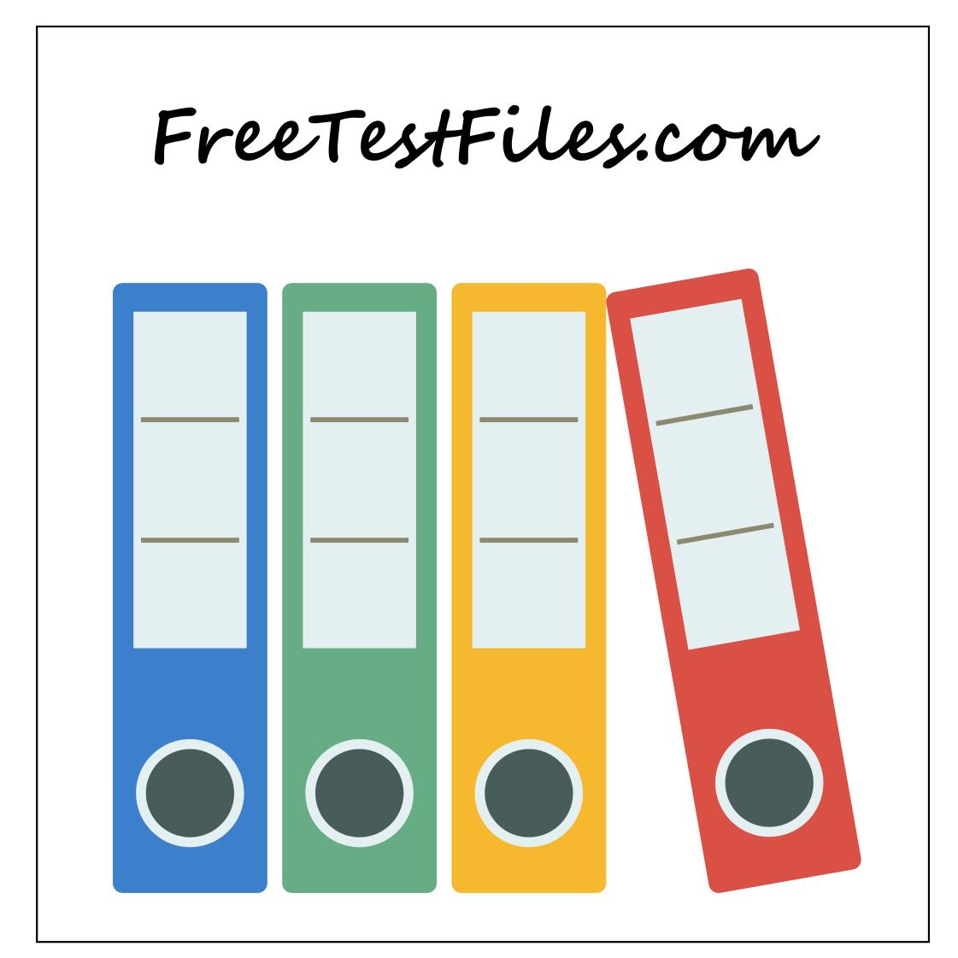

Get in Touch

If you have questions, suggestions, or feedback, feel free to contact us:

📧 Email: contact@freetestfiles.com

We value user input and strive to make FreeTestFiles.com more useful every day.

Thank You

Thank you for visiting FreeTestFiles.com.
We hope our resources help you test, learn, and work more efficiently.

Our Purpose
In today’s digital world, testing is an essential part of everyday work. Whether you are checking internet speed, testing software compatibility, validating upload limits, evaluating device performance, or learning how different file formats behave, you need clean and trustworthy sample files.

FreeTestFiles.com was created to solve this exact problem by offering a centralized collection of commonly used test files in multiple formats and sizes.

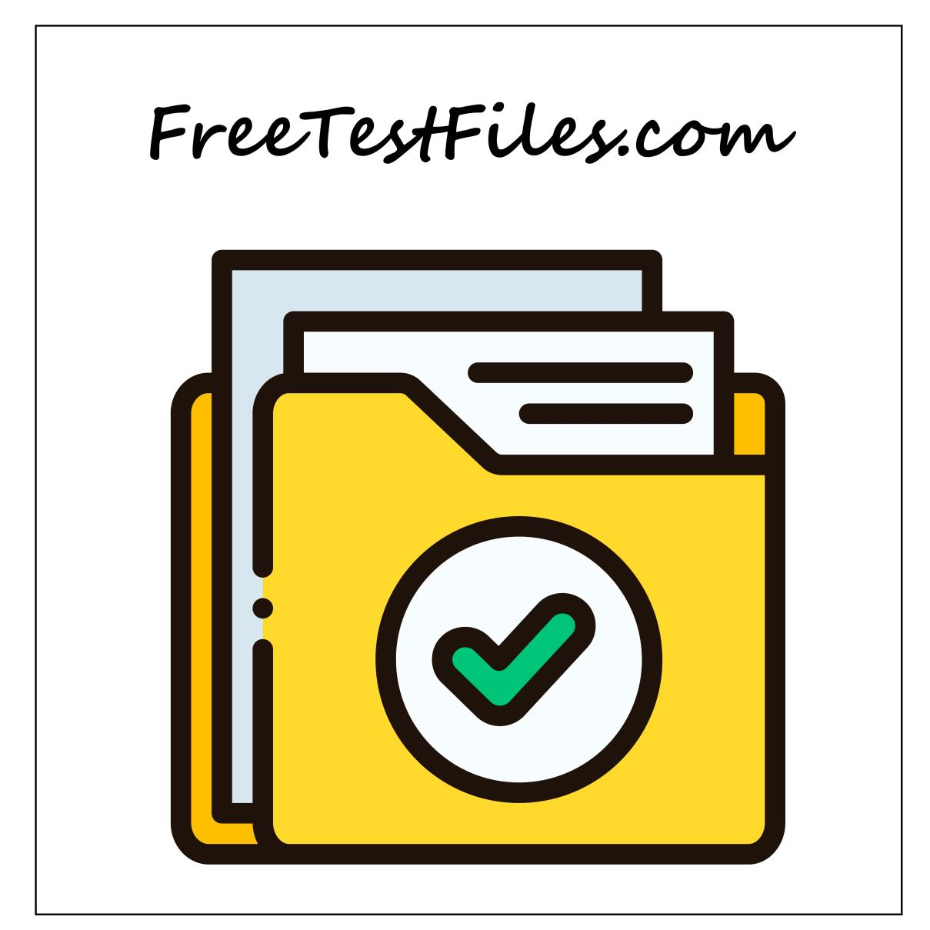

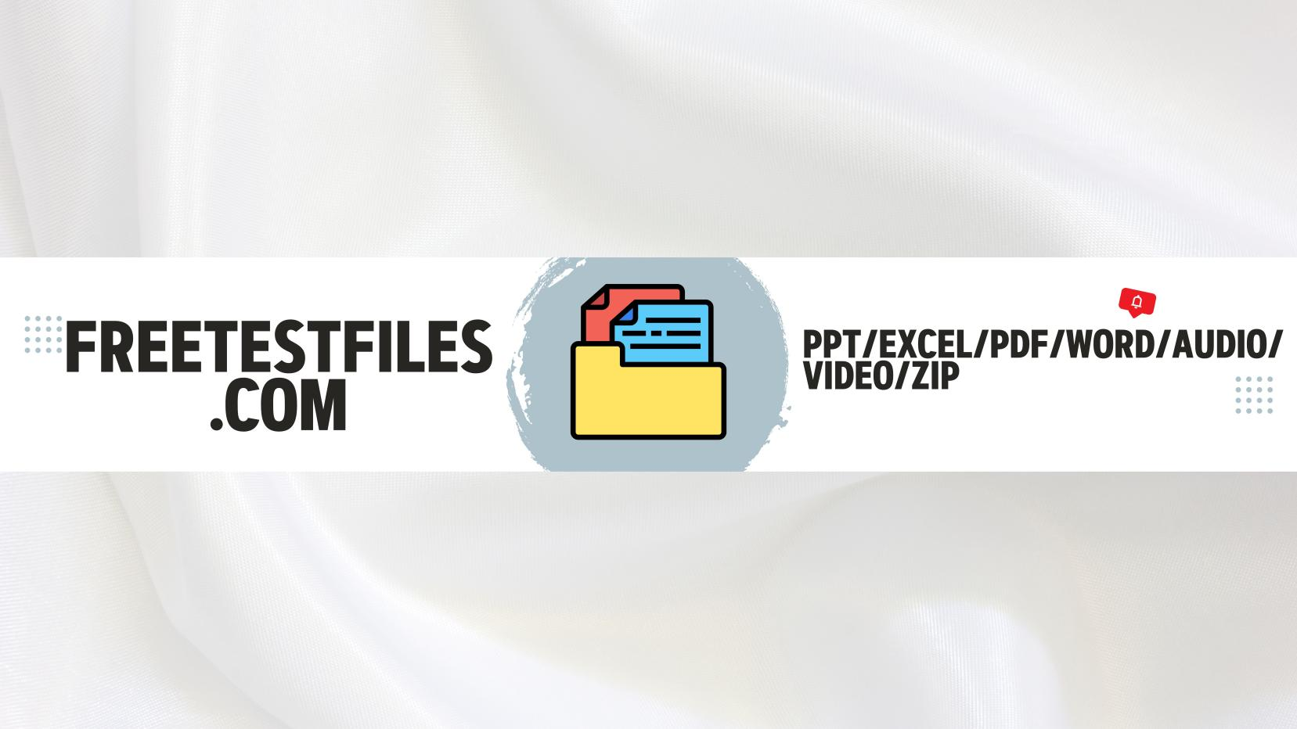

Disclaimer

All files provided on FreeTestFiles.com are intended only for testing and educational purposes. They are not meant to replace original documents, licensed media, or professional resources. By using this website, users agree to use the files responsibly and for lawful purposes only.

Get in Touch

If you have questions, suggestions, or feedback, feel free to contact us:

📧 Email: contact@freetestfiles.com

We value user input and strive to make FreeTestFiles.com more useful every day.
Thank You
Thank you for visiting FreeTestFiles.com.
We hope our resources help you test, learn, and work more efficiently.
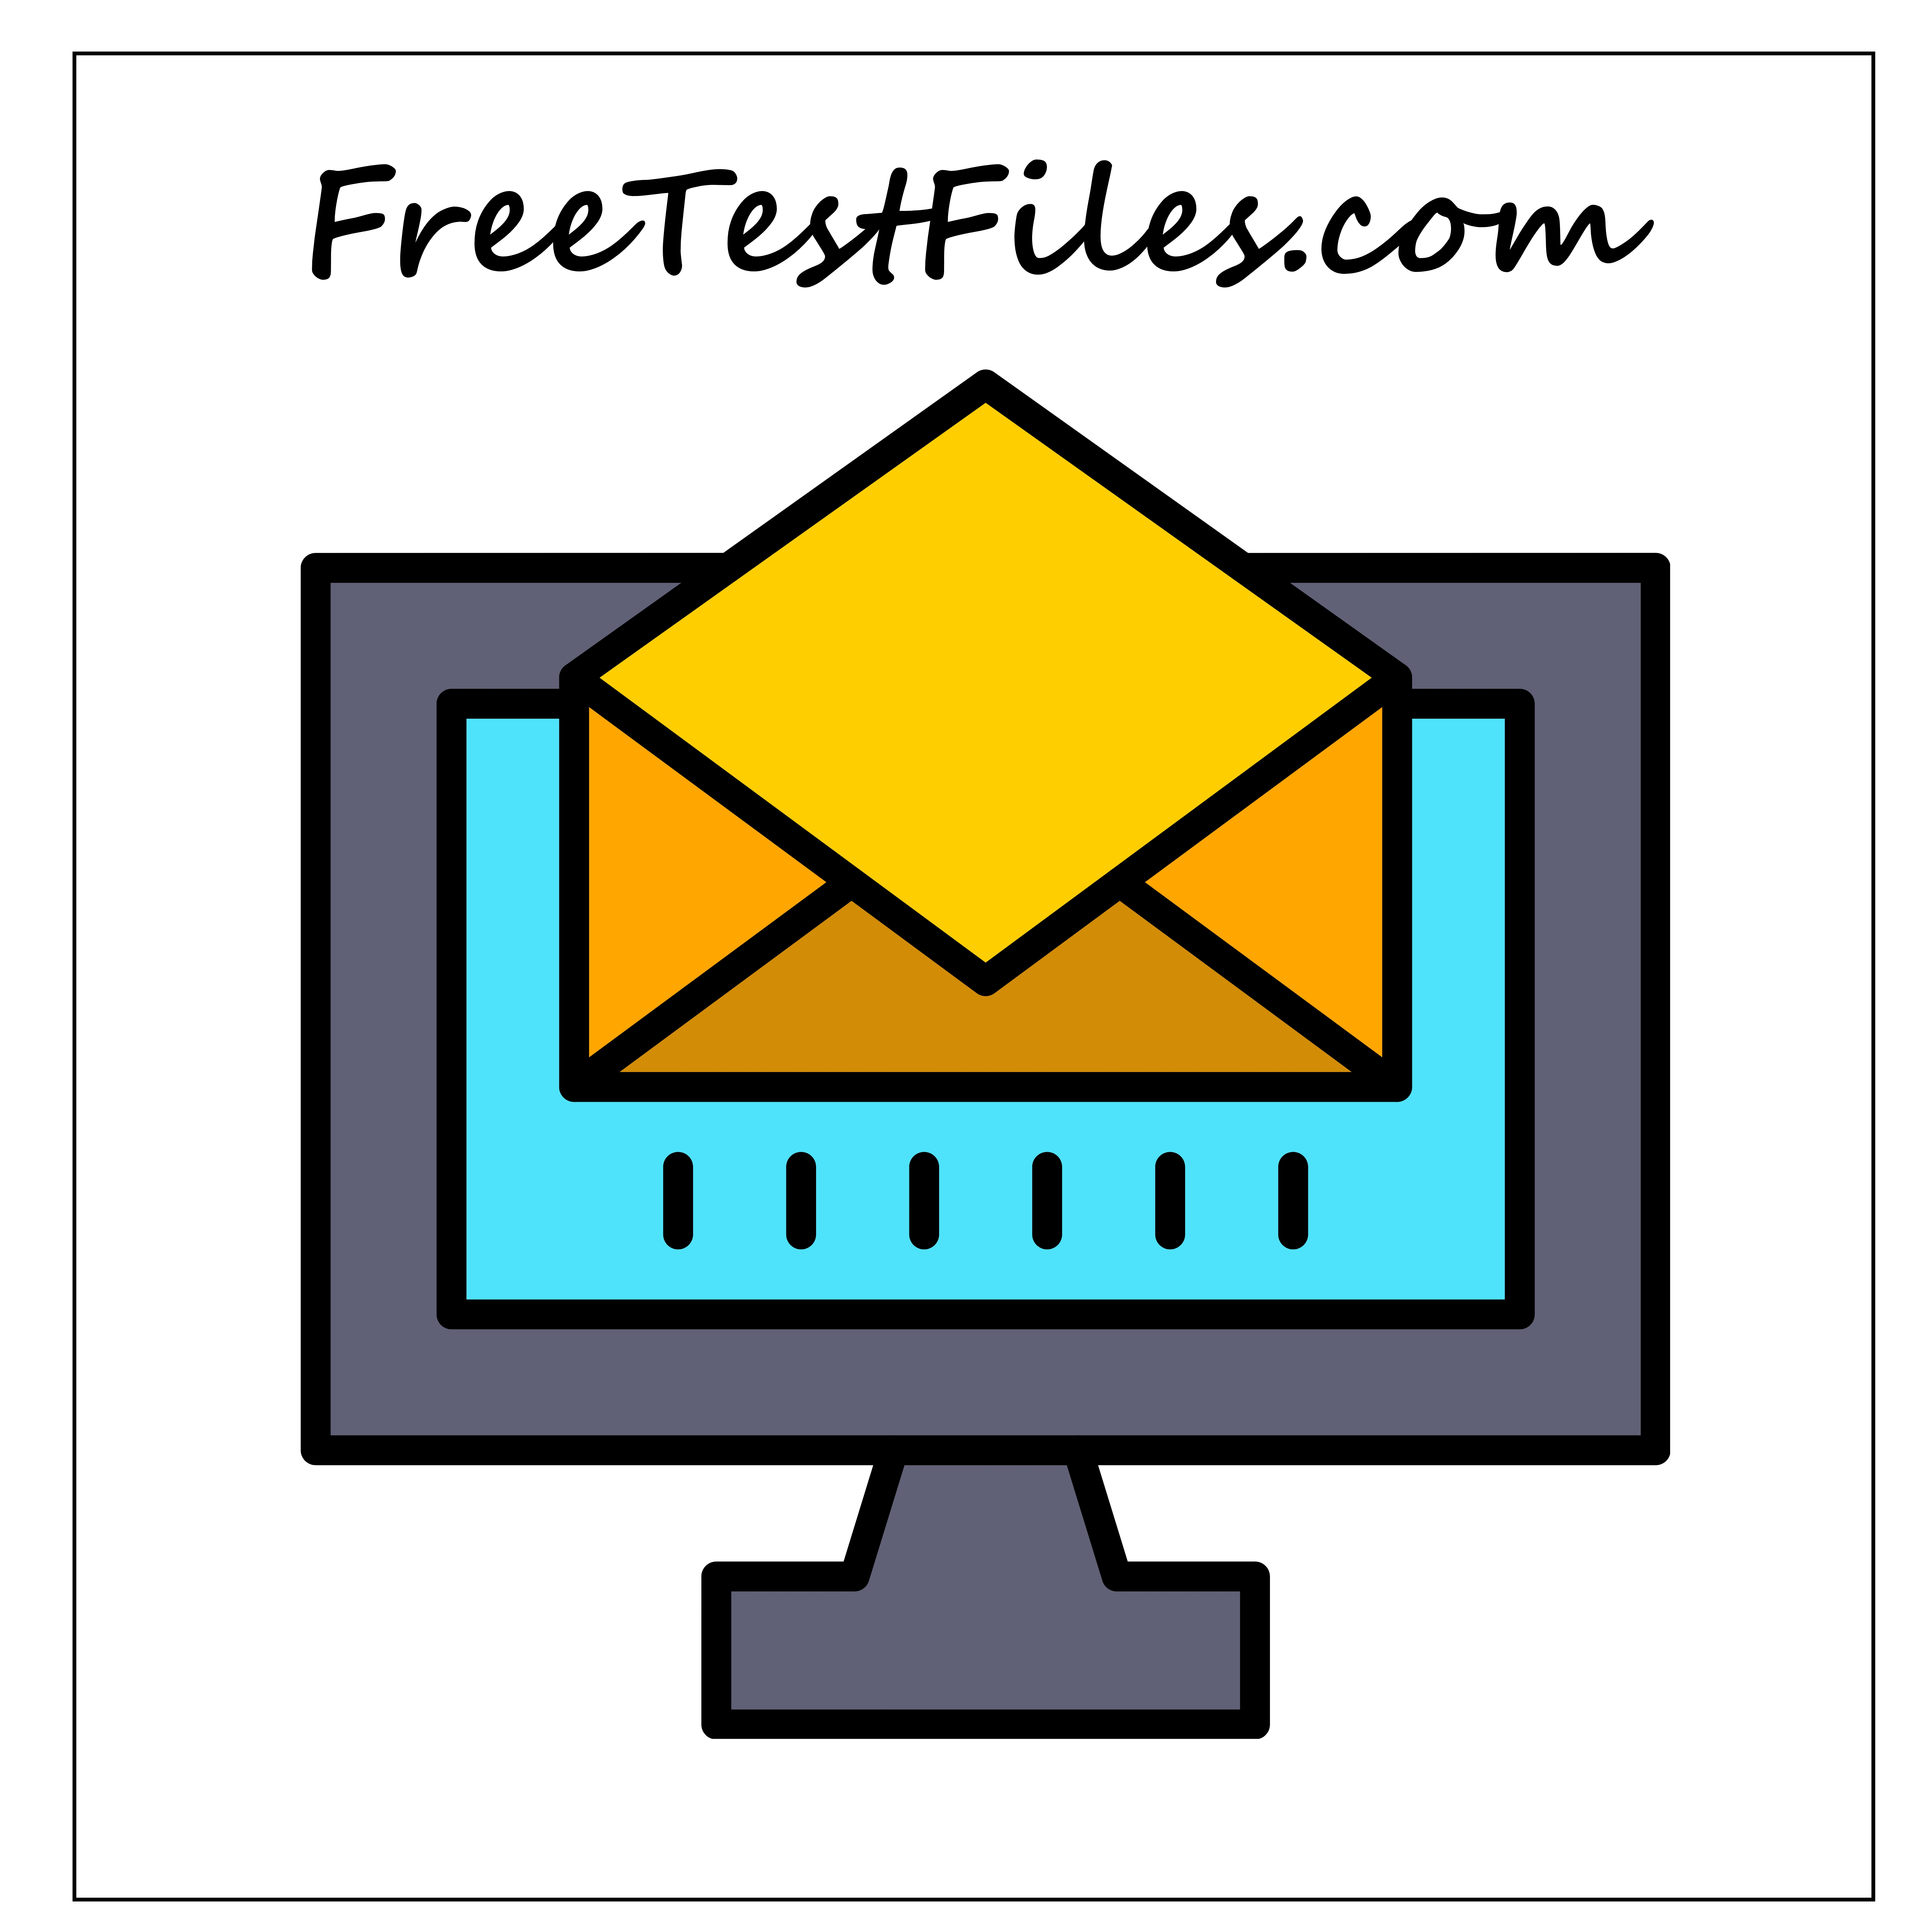

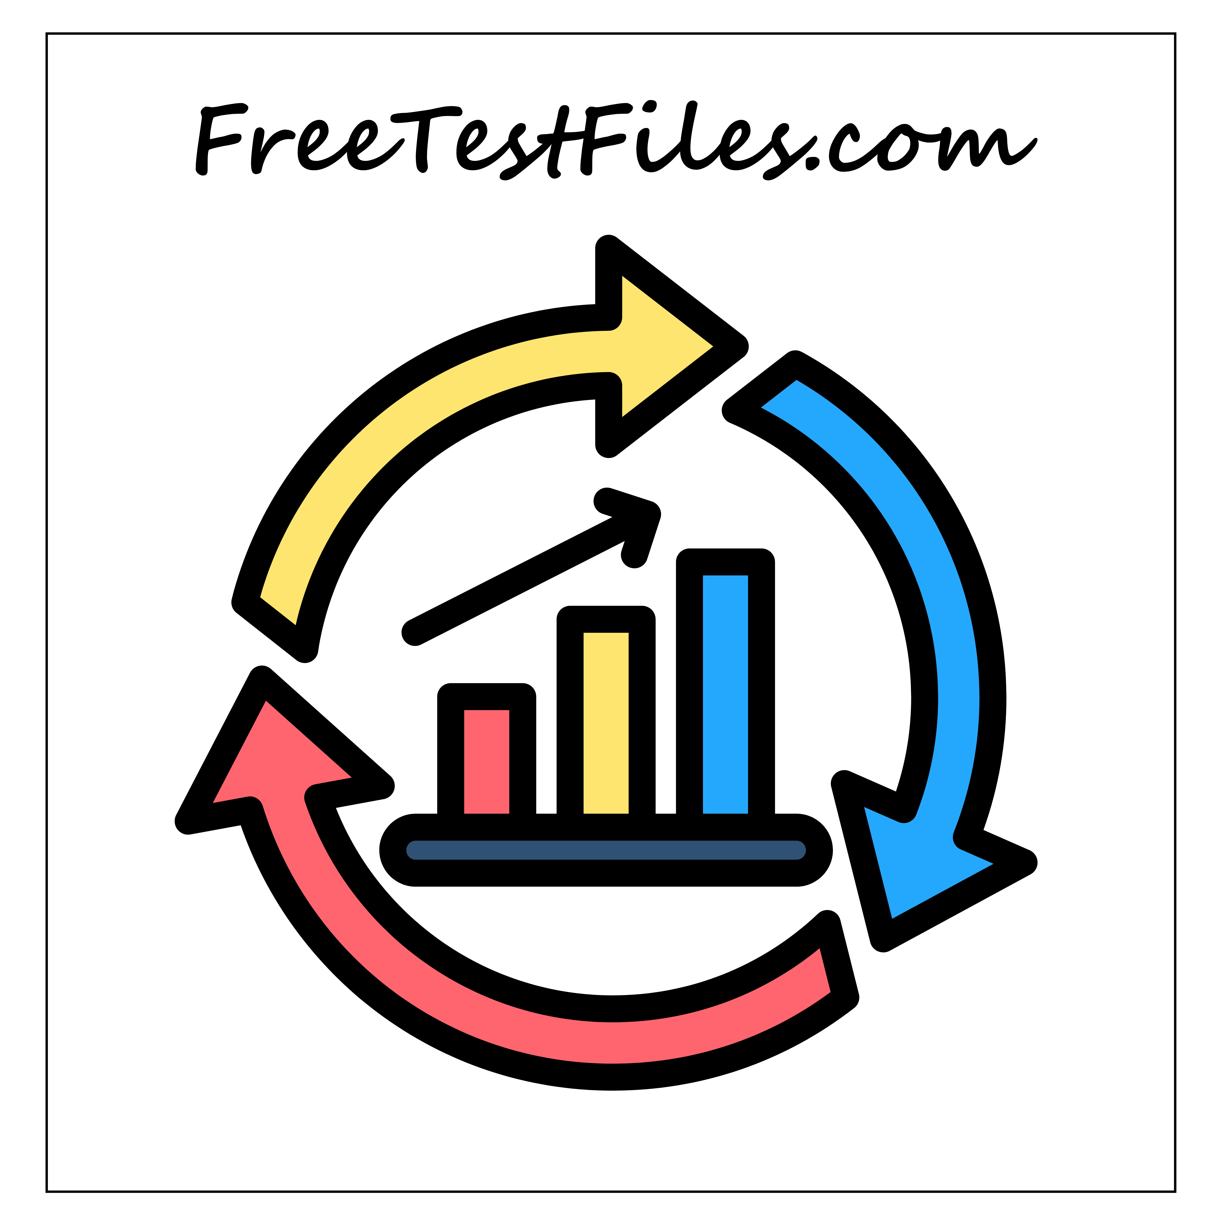

Who Uses Our Website

- Our users come from a wide range of backgrounds, including:

- Students and learners

- Developers and testers

- IT professionals and system administrators

- Network engineers and internet users

- Educators and trainers

- Anyone who needs sample files for legitimate testing can benefit from our resources.

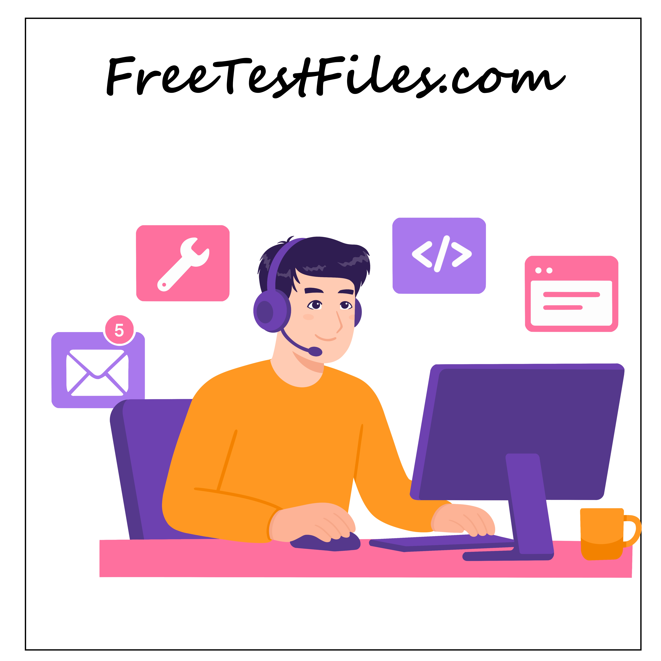

Why FreeTestFiles.com Exists

Many users struggle to find trustworthy sample files without encountering broken links, misleading downloads, or unsafe content. Our platform focuses on:

Simplicity – Clear file sizes, formats, and direct downloads

Reliability – Stable hosting and consistent access

Transparency – No hidden actions or forced registrations

Accessibility – Files available 24×7 for users worldwide

We believe testing resources should be easy to access and free to use.

Our Commitment to Quality & Safety

All files available on FreeTestFiles.com are:

Created specifically for testing purposes

Free from malicious scripts or executable code

Regularly reviewed to ensure accuracy and usability

We do not host pirated software, copyrighted media, or unauthorized content. User safety and trust are always our top priorities.

